This summer the Cy-Falls Men’s Basketball Staff will conduct their annual BOYS BASKETBALL CAMP.

**Date**: Tues May 30th – Thurs June 1st

**Time**: 9 am - 12

**Location: Cypress Falls HS**

This camp is for players **entering the 7th, 8th & 9th grade.**

**Cost:** $75 Cash

## Basketball Skills Camp

_______________________

_______________________

_______________________

_______________________

 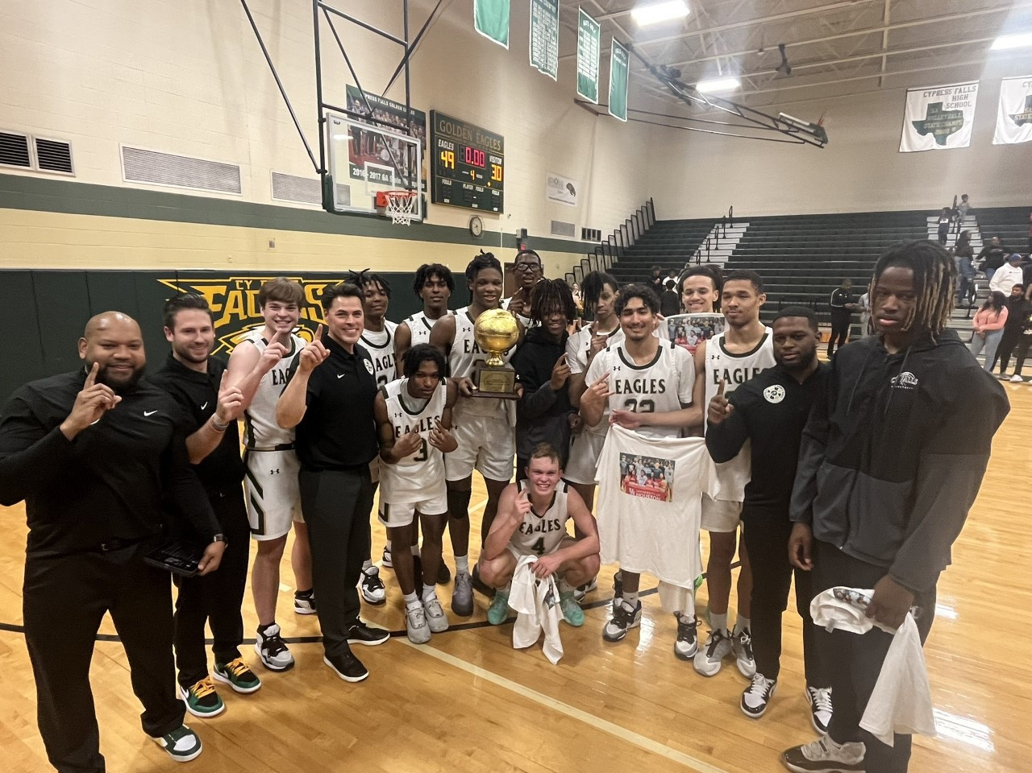

BACK TO BACK

DISTRICT CHAMPIONS

Cypress Fairbanks ISD

Cy-Falls High School

9811 Huffmeister

Houston, TX 77095

ATTN: RICHARD FLORES

Postage

Here

Phone: 281-856-1052

E-mail: Richard.flores@cfisd.net

May 30th – June 1st

9 am - 12

* **All athletes that participate in a CFISD camp will need to have a current physical on file and available at the camp site.**
* **All athletes that participate will need to fill out the athletic participation consent form before participating (Appendix 19 in CFISD handbook).**

STUDENT'S NAME: ____________________

CAMPUS:_____________________________

I hereby give my consent for the above named student to participate in school athletics

including various athletic practices, competitions and camps. I understand it is my responsibility to provide health insurances coverage for this student. I further understand CFISD is not liable for any injuries resulting from participation in school athletics. If in the judgment of any representative of the school, this student needs immediate care and treatment as a result of any injury or sickness, I do hereby request, authorize and consent to such care and treatment as may be given to said student by any physician, trainer, nurse, hospital or school representative.

**DATE:_______________________________**

**PARENT/GUARDIAN NAME**:

**_____________________________________**

**SIGNATURE OF PARENT/GUARDIAN**:

_________________________________

Camper Application

Player Name

Middle School

**\*Please attach physical to form**

**\*Register BY MAY 26TH to ensure T shirt size**

Adult T-Shirt Size (Circle One):

S M L XL

Address

City, State, Zip Code

Home Phone Number

Cell Phone Number

Emergency Contact Name

Emergency Contact Phone Number

Email Address

## CFISD ATHLETIC POLICY

# GET BETTER!!!

**What:** Our coaching staff consists of highly qualified high school coaches who will help your child with all the necessary skills to become a better basketball player.

**When**: Tues May 3Oth – Thur June 1st

**Time**: 9 am - 12

**Where**: **Cypress Falls HS**

**Who**: Entering 7th, 8th & 9th grade

**Cost**: $75 Cash Only